

**Department of the Army**

**North Paulding High School**

**ARMY JROTC**

**300 North Paulding Dr.**

**Dallas, GA. 30132**

To: Parents, Guardians, and Cadets

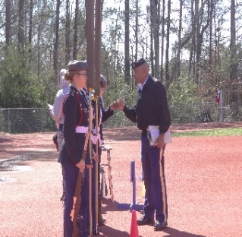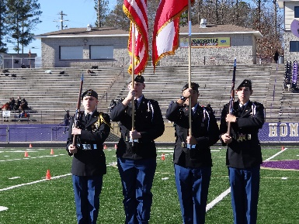**NPHS Drill team**

Coach Master Sergeant Briggs

Email mbriggs@paulding.k12.ga.us

**Team Description –** Drill Team is North Paulding’s JROTC marching unit that is based upon military drill. The overall Drill Team is a series of teams that compete in competitions called Drill Meets. The Drill Meets are judged upon precision and accuracy. Drill Meets are held on Saturdays and are the season runs from Nov 6th – March 23th

**Schedule –** Monday (Unarmed), Tuesday (Armed), Wednesday (Color Guard), Thursday (All)

**Equipment Provided –** Color Guard: Class A Uniform, Harness, and Exhibition Rifle.

Armed: Class A Uniform and Exhibition Rifle

Unarmed: Class A Uniform

**Transportation to Competition –** Personal vehicle and carpool

**Student Cost** – $50 – For food after Drill meets

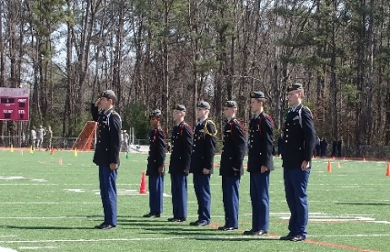**Student Commitment** – Practice – Monday, Tuesday, Wednesday, and Thursday from 3:30 to 5:30

