



**Department of the Army**

**North Paulding High School**

**ARMY JROTC**

**300 North Paulding Dr.**

**Dallas, GA. 30132**

To: Parents, Guardians, and Cadets

**NPHS Raider Team**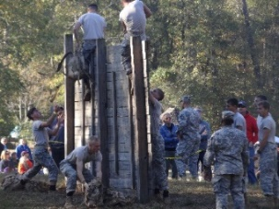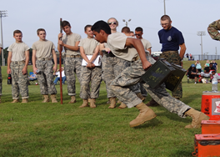

Coach Master Sergeant Briggs

Email mbriggs@paulding.k12.ga.us

**Team Description:** Raider Team is an athletic team, in which JROTC cadets can compete in obstacle courses, strength based events and running events. As a team you will participate and work together to accomplish around 5 events at each meet. These events include 5k, Team Run, Rope Bridge, CCR, Raider Fitness Challenge, and Tire Flip.

**Practice:** Monday – Thursday

Meets: most Saturdays in September & October, Nationals: Friday, Saturday, and Sunday of first week in November

**Equipment Provided:** ACU Uniform, Boots, and Tan t-shirts, Team t-shirts and hoodie

**Transportation to Competition:** Personal vehicle, Carpool

**Student Cost:** $100 – Two Raider t-shirts, Hoodie, and Uniform

**Student Commitment:** Practice is Monday – Thursday 3:30 – 5:30

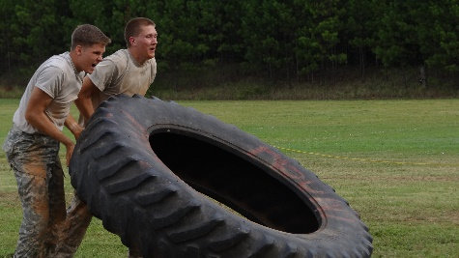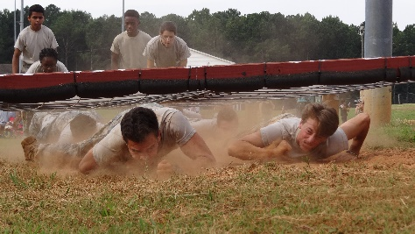The Raider Lifestyle – No junk food, candy, soda during the raider season. The day before a raider meet eat carbs such as pasta. Stay hydrated, drink plenty of water. Get at least eight hours of sleep the night before.