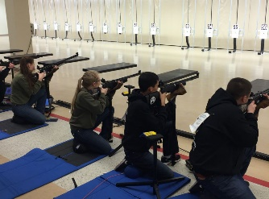
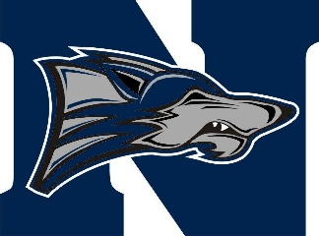

North Paulding High School
300 North Paulding Dr.
Dallas, GA. 30132

To: Parents, Guardians, JROTC Cadets, and North Paulding Students 8/15/2018

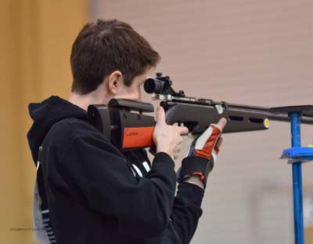
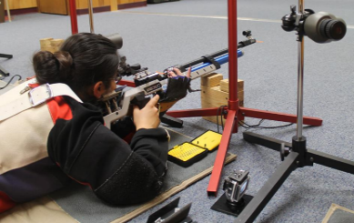
NPHS Rifle Team
Coach Lieutenant Colonel Lesnieski
Office# 706
Email: TL16622@paulding.k12.ga.us
Team Description – Rifle Team is North Paulding’s Georgia High School Association precision marksmanship team. We, as a team, will practice after/before and after school to improve our accuracy, which will therefore improve our overall team score in meets. Meets are usually on Thursday, but on rare occasions Saturdays. We will take five to six people to each meet but the team will consist of ten members. The Rifle Team will have a total of ten meets throughout the season.
Schedule – Practice Monday/Tuesday/Wednesday 3:30 – 5:00 in Rm 705
Competition – Thursdays – 3:30 – TBD
Competition Schedule – Dates and Location
Equipment Provided – Shooting Jackets, Gloves, Olympic Level Pellet Rifle, Shooting Mat, and Rifle Stand.
Student Cost - $75 – Pays for Pellets, Targets, Long Sleeve Shirt, and Windbreaker with team logo.
Transportation To Competition – Personal vehicle, Carpool, Coach
Student Commitment – Every Monday, Tuesday, and Wednesday is Rifle Team practice from 3:30 to 5:00. Competitions will be held on Thursday’s, excluding the last competition which will be held on a Saturday.
“Precision Matters”
“Aiming For Excellence”

